THE ROOTS of ENGLISH answers
The English language is a sponge. It absorbs words from every language on earth, even languages you’ve probably never heard of! Do you know where these English words come from?
1 French 2 Italian 3 Dutch 4 Spanish 5 Arabic
_2 salami _3 gin _1 baguette _2 lasagne _5 algebra _3 iceberg _4 paella _4 chorizo _3 waffle _5 alcohol _4 sherry _1 biscuit _3 cookie _1 restaurant _2 latte _3 yacht _2 graffiti _4 tornado _1 route _3 boss _3 meerkat _1 duvet _5 cotton _3 rucksack _1 ballet _1 pork _4 cargo _5 lemon __4 canyon _5 tuna _1 bouquet _5 mattress _5 mummy _4 jalapeno _1 garage _1 dam _4 nachos _3 coleslaw _2 pizza _5 admiral _2 pronto _2 ravioli _1 cul de sac _3 booze _3 geek _2 cafeteria _1 sabotage _2 pasta _4 fajita _5 sugar _3 landscape _2 piano _1 pâté _5 admiral _4 fiesta _2 orchestra _1 potpourri _4 siesta _1 croissant _5 cipher _2 fresco
South America, India, Canada or China?
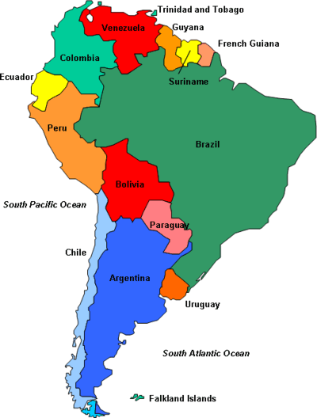

I ketchup SA potato CH silk I curry I shampoo CH soy C anorak CH tycoon C kayak C igloo C tepee C chipmunk C husky I jungle I pukka CH wok SA pecan C skunk I chutney C toboggan SA tobacco I bangle SA jaguar C moose I thug SA cannibal C tai chi SA barbecue C anorak CH tea C canoe SA tobacco I bungalow SA hammock CH kung fu SA cougar I veranda SA puma I dinghy SA bandana C moccasin I juggernaut SA piranha I pyjamas SA hurricane SA cocaine
1 German 2 Japanese 3 Nahuatl 4 Scandinavian languages
_4 fjord _2 koi _3 tomato _1 poodle _ 2 judo _4 lemming _2 tofu _4 tungsten _1 muesli _3 chilli _1 cake _4 reindeer _1 dachshund _3 avocado _4 slalom _2 soya _2 sushi _2 karate _1 moped _2 sudoku _3 shack _1 rottweiler _2 tsunami _4 loft _2 karaoke _3 chocolate _1 lager _1 abseil _1 kindergarten _2 satsuma _4 husband _1 Neanderthal 3 _cocoa _4 ski _1 schnapps _2 origami
Ancient languages 1 Celtic 2 Latin 3 Greek
_1 bog _2 amoeba _1 galore _2 zone _1 hooligan _3 psychology 1 phoney _1 whisky _3 acne _3 biology _1 penguin _3 halogen _3 arctic _3 octopus _2 epiglottis _2 diet _3 helicopter _2 maximum _3 therapy _2 centre _3 geometry _2 strontium _1 trousers _3 oxygen _1 Tory _3 hippopotamus _1 clock _2 school _1 corgi _3 hygiene _1 leprechaun _2 physics _3 horoscope _3 astronomy _1 shamrock _3 genetic _2 diary _1 pet _1 gob _2 canine _2 forest _2 glacier _2 library _2 medium _2/3 sociology _2 neutral _3 alphabet _2 number _ 2 salary _2 village
So far we’ve seen (relatively) well known languages – how about lesser known ones? Feeling brave?
Turkish 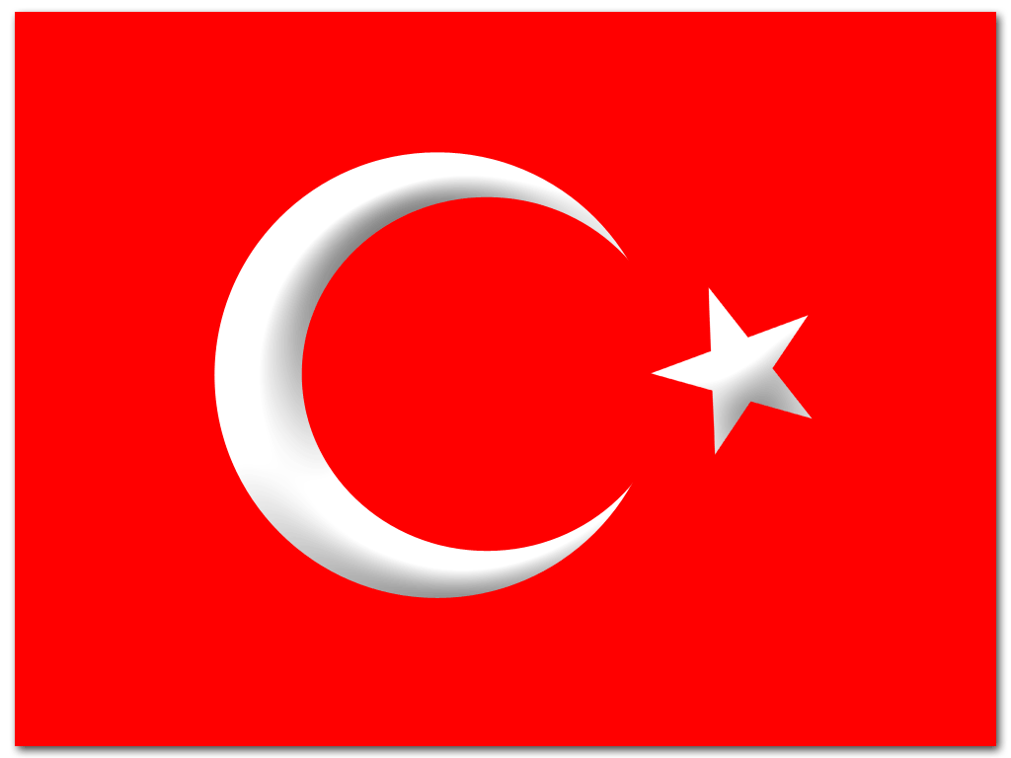 Portuguese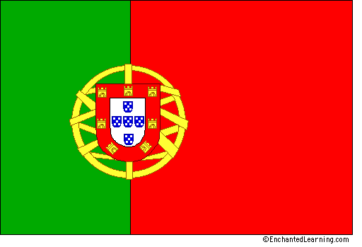 Persian Hebrew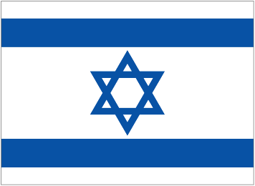

PE checkmate T tulip T shish P marmalade PE cinnamon H cider H alleluia H messiah H pita PE satin H sycamore T kebab P albino P albatross P banana P breeze P cobra P mosquito P tank PE kaftan T kiosk H pastrami T turquoise T Urdu T yurt PE balcony PE bronze T yoghurt PE caravan PE lilac PE magic PE naan PE orange T Pakistan PE samosa
Food, glorious food but where does it come from?
Sushi __Japan_______ Paella ___Spain_______ Coq au vin ______France_____
Doner kebab ___Turkey_______ Ravioli ____Italy____ Sauerkraut ___Germany____
Chow mein __China_____ Nachos ___Mexico____ Chicken Korma ____India____
Sometimes we use foreign words in English even when we have our own English words – what do these words mean and from which language do they come?
English meaning language
ciao __hi/bye______ ________Italian________
gesundheit __bless you_________ ______German_______
mazel tov _congratulations_____ ________Hebrew_______
bon voyage _have a good trip____ _______French________
sayonara _good bye___________ _______Japanese_______
amigo _____friend______ _____Spanish_______
sláinte __cheers________ _________Irish_______
hakuna matata __no problems______ ________Swahili______
hasta la vista _________see you_____ ________Spanish_______
rendez-vous ____meeting______ __________French_____

